5
Playing with IronRuby and Silverlight
This chapter covers
- Setting up your development environment
- Building a Silverlight application from scratch
- Using controls made with Expression Blend
- Dynamically adding controls using Ruby
- Accessing web services

What's the point of a great graphics framework if you're not going to make games with it? And what self-respecting programming book doesn’t include a retro game code sample?
In this chapter we'll build our very own Tetris clone, Gemtris. We'll ask our talented & arty new friend Silverlight to provide the graphics, and power it on the backend with IronRuby.
Silverlight is Microsoft's platform for delivering next generation web experiences, and takes a large step towards providing desktop-like functionality in your web browser. Because Silverlight runs a subset of the .NET framework (known as the CoreCLR), Dynamic Language Runtime (DLR) language’s like IronRuby can also run in this environment. This means that without much pain developers can transfer their existing .NET knowledge and, to some degree, their existing code.
But before we can do any coding you’ll need to get your environment setup for developing DLR powered Silverlight applications.

5.1 The Silverlight DLR development environment
First of all, to view any Silverlight application you’ll obviously need to install the Silverlight browser-plugin from http://www.silverlight.net, if you haven’t done so already.
Apart from that all the required files for Silverlight development should have been installed along with the IronRuby installation outlined in Chapter 1.
The Silverlight DLR tools are included within your IronRuby’s installation folder. It’s a good idea to make sure the IronRuby installation has set up your PATH environmental variable correctly to include these paths.
Listing 5.1 Checking your PATH includes the IronRuby Silverlight directories
For Windows users:
» PATH
PATH=…C:\Program Files\IronRuby 0.9.2\silverlight\script\;C:\Program Files\IronRuby 0.9.2\silverlight\bin
For OS X users:
» echo $PATH
…/usr/local/ironruby/silverlight/bin:/usr/local/ironruby/silverlight/script
5.1.1 The sl Silverlight application generator tool
The sl tool is a simple Silverlight application generator, which in practice means creating a new folder and copying some template files into it.
The parameters are very simple. The first is the language, “ruby” for IronRuby in our case, and the second is the desired name of your Silverlight application, which will be the name of the folder created to contain your application.

Usage: sl [ruby|python] <application_name>
Creates a Silverlight application in the "application_name" directory.

The outputted application directory contains the following files and folders.
5.1.1.2 Files and folders generated by sl
Name | Description
app/ | Application XAML and code
app/app.rb | Main IronRuby class and XAP entry point
app/app.xaml | Application XAML
css/ | Template application stylesheets
js/ | Template application javascripts
index.html | The HTML hosting the Silverlight browser control

Customising sl’s template
It’s simple to customize the standard template used by sl. You’ll find the template under your IronRuby installation folder in silverlight/scripts/template/ruby/.
5.1.2 The Chiron development web server
Chiron is a lightweight web server included with IronRuby, and can be found under the IronRuby Silverlight folder at silverlight/bin/chr. It is intended for localhost development use.
Chiron’s big party trick is producing Silverlight application packages (XAP’s) for DLR powered Silverlight applications for each incoming web-request, saving you the hassle of a packaging step when debugging development code.
The XAP file automatically generated by Chiron is essentially a ZIP file containing your application directory, the assemblies required to run it, and the AppManifest.xaml file providing details of application assemblies and an entry point.
There are a few command line switches for chr. Running chr without any switches will show you the help page with the full list of all possible switches.
Table 5.2: Some useful Chiron command line switches
Switch | Description | Sample
/w or /webserver | Launch the development web server and create the XAP file.  Optionally specify the port with /w:PORT | /w  /w:8080
/b or /browser | Launch a web browser for the newly launched web server (/b implies the /w switch).  Optionally specify the URL with /b:URL | /b:index.html
/z or /zipdlr | Generate a XAP file with DLR DLLs and auto-generated AppManifest.xaml if it doesn’t exist.  Cannot be combined with /w or /b. | /z:gemtris.xap
/m or /manifest | Generate an AppManifest.xaml file on disk. | /m
/p or /path | Include an additional directory in the XAP file. | /d:images/:sounds/
/x or /xap or /xapfile | Specify the XAP filename. Doesn’t include DLR DLLs or generated AppManifest.xaml (use /z for that).  Cannot be combined with /w or /b. | /x:gemtris.xap
Debugging your generated XAP files
Sometimes it’s helpful to see what exactly has gone into your XAP file.
Your XAML image might not be showing up, for instance. Peeking into the XAP file will quickly remind you that the file is outside of the app path, and you need to add a /path switch to the Chiron command.
Since a XAP is really just a ZIP file it’s a pretty simple process to extract its files.
+adam@adam-mbp: unzip gemtris.xap /d outputdir
5.2 Creating the Gemtris IronRuby Silverlight project
Lets start by running the sl tool with the name of our new project. This will then generate a new Silverlight application structure for us to work in.
5.2 Generating an IronRuby Silverlight project with sl
» sl ruby Gemtris

Ruby Silverlight application created in 'Gemtris/' directory.

You should receive a success method telling you the directory has been crated. Let’s see what that has made for us.
5.2.1 Spin her up!
The eager reader may have already discovered that just double clicking on the index.html file will not show you anything just yet. The index.html is currently referencing a non-existent XAP file. We haven’t manually compiled a XAP file for the project or it off a running Chiron web server instance, which would have dynamically generated one for us. Lets start up the Chiron web server so we can see our current progress.

» chr /w /b:index.html

Chiron will generate the XAP file and open the index.html file on a localhost URL in a web browser, showing you the standard template for a new IronRuby Silverlight application, the IronRuby Console; a Hello World, REPL, and debugging environment all in one.
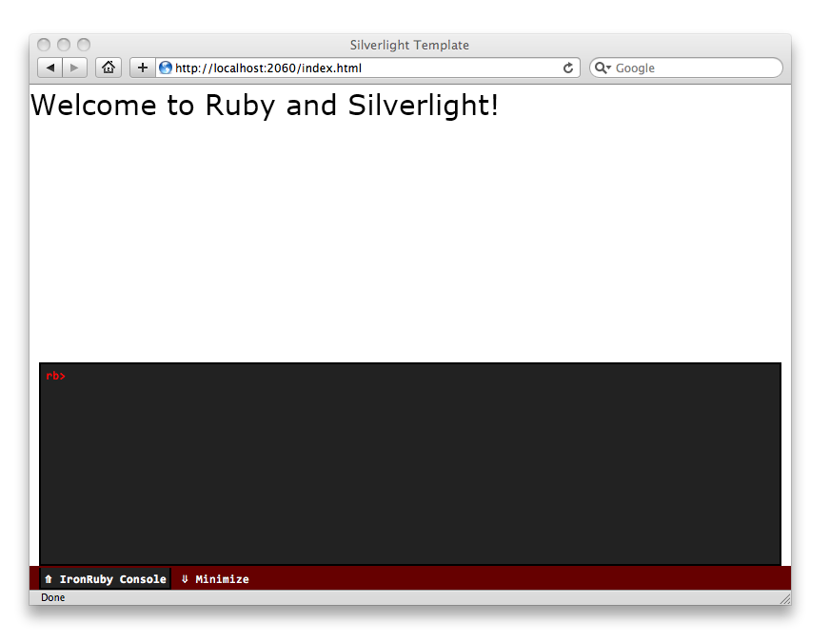
IronRuby Silverlight’s equivalent of “Hello World”, the IronRuby Console
Looking at the generated code
If you got the “Welcome to Ruby and Silverlight” screen then it worked. Great stuff! What’s going on behind the scenes in IronRuby? Lets open up the generated app.rb file and have a peek, and learn a bit about accessing the root visual element of the XAML application.
##.## app.rb accessing the root visual element
include System::Windows
include System::Windows::Controls

class App
def initialize
@root = Application.current.load_root_visual(UserControl.new, 1
"app.xaml")
@root.find_name('message').text = "Welcome to Ruby and Silverlight!" 2
end
end

$app = App.new

The real work here is being performed by the Application.current.load_root_visual #1 method which is loading the app.xaml and making it visible in the control, and returns a reference to this root element which is stored in a class variable for future use #2.
Embedding Silverlight in HTML
Being a web-browser plugin we’ need to add a Silverlight Object reference in an HTML page in order to see anything. The index.html file generated by the sl tool must obviously have done this for us already. In the simplified case it’s a matter of specifying the following canonical snippet of HTML, as provided by MSDN http://msdn.microsoft.com/en-us/library/cc189089(VS.95).aspx
##.## HTML for embedding Silverlight
<object width="300" height="300"
data="data:application/x-silverlight-2,"
type="application/x-silverlight-2" >
<param name="source" value="SilverlightApplication1.xap"/>
</object>
Brilliant! You’ve now mastered the steps of creating your first IronRuby Silverlight application. Nothing can stop you now from creating the web’s next killer app. For now though, lets start off easily by creating a simple game, Gemtris.
5.3 Starting at the front
Perhaps, like me, you're most comfortable on the front-end of the development divide. Whenever I'm faced with a new application I like to see things through the end user's eyes, meaning of course the user interface. It’s also a great way of discovering hidden requirements. Jotting out a wireframe sketch on a napkin always helps:
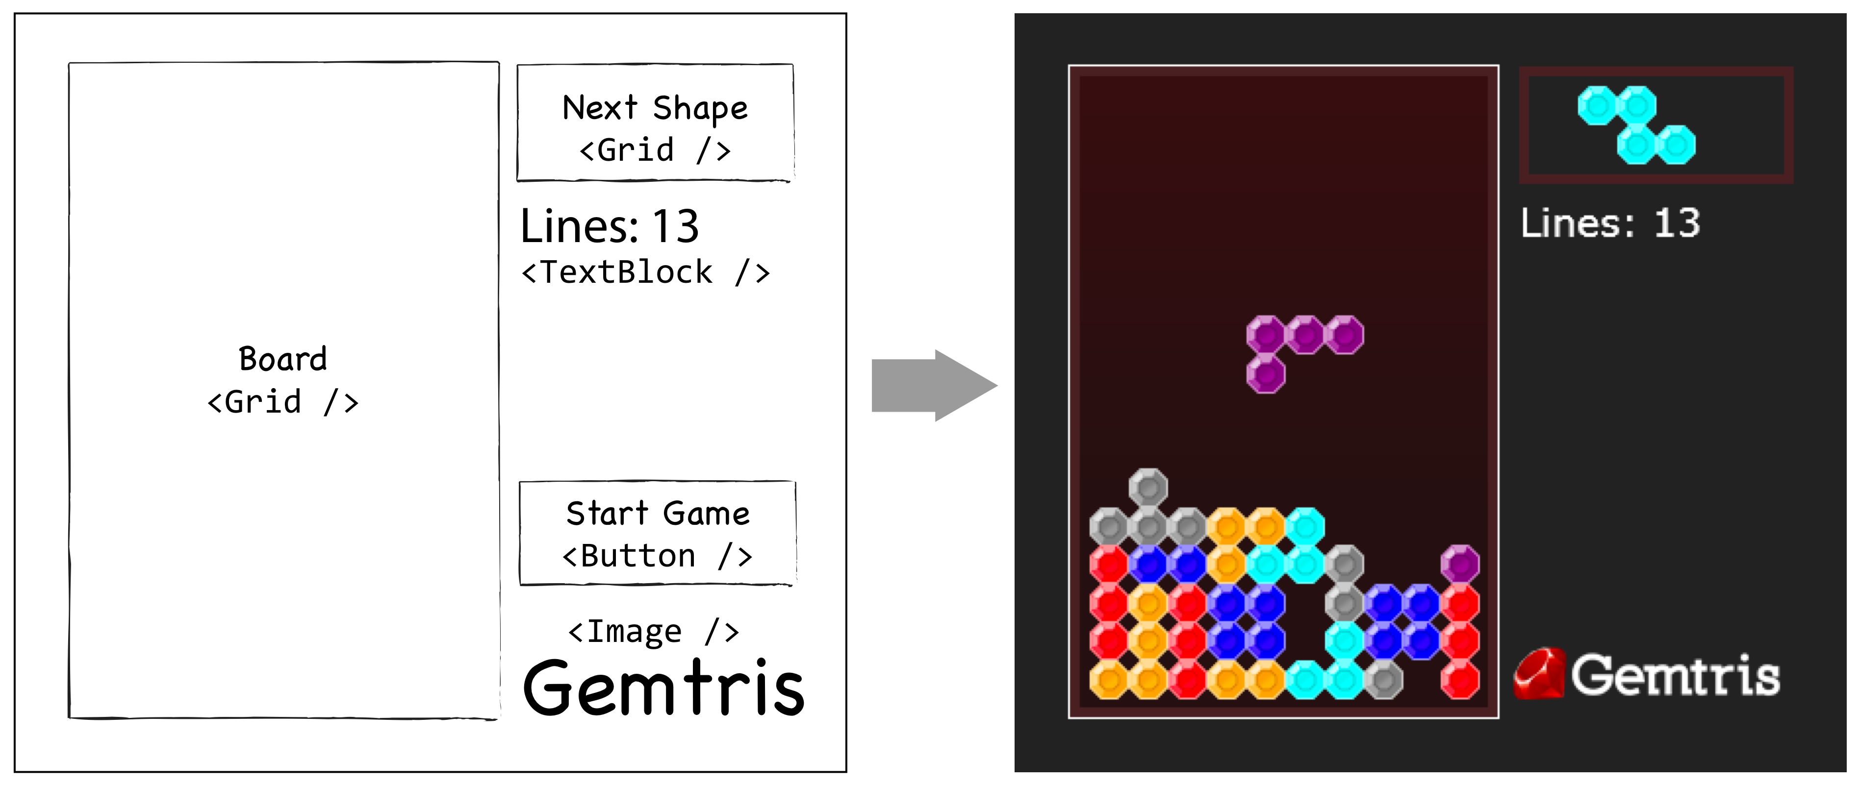
Wireframe and final design for Gemtris, a IronRuby Silverlight Tetris clone
From the wireframe we can quickly identify a number of XAML elements. The structured table-like nature of the Grid element is a good fit for laying out the blocks. We’ll also need a TextBlock for the lines-completed count, a “Start Game” button, and an Image for the gratuitous branding logo.
Looking at this we can also see we are going to need to organize a couple of graphical design elements from our friendly local designer (unless you’re multi-talented). Since this is a Tetris clone, the first element we’re going to need is some sort of block piece. Lets be original and use a Gem graphic for our block piece. The creative juices are flowing!
5.3.1 Pick your design tools
There are many ways of generating the XAML required for our project. You could use Microsoft Visual Studio, Expression Blend or Design, Adobe Illustrator, and a whole range of programs capable of exporting XAML.
Good news everybody! The choice is yours. Any of these will provide a similar end result. You’ll probably find that you’ll use a combination of these applications within your workflow. In my case, while implementing Gemtris, I firstly designed the Gem piece in Adobe Illustrator, imported it into Expression Design to tweak it, then used Expression Blend to build it into a C# UserControl. Why a C# UserControl, this is a book about dynamic languages, right? In the next section we’ll look at some of the current limitations of using a dynamic language with Silverlight, and some workarounds.
XAML and Dynamic Languages: Know Your Limits!
Ideally we’d like to build a full range of Gemtris controls so we could
<gemtris:Board />
5.4 “Hello, Coloring In Team? I need a Gem”
A basic requirement for a Tetris game is the blocks need to come in a range of colors. Because we’re clever developers and designers, and because we want to do as little work as possible, we’re going to make use of Silverlight’s excellent opacity support and only create a single gem piece that reusable for all possible colors.
The secret here is using a solid background shape with a series of highlights with varying opacity sitting in the layers above.
Creating a new Expression Blend project
Expression Blend makes it easy for designers and developers to collaborate together on a shared project. Designers can tweak the XAML shapes and layers, naming elements as they go, and then pass it on to developers to add their own changes and code-behind, before finally building the control library into a .NET Assembly.
To enable this collaboration we need to create a new Expression Blend project. In the New Project window select the Silverlight 3 Application + Website option to create the solution and class library files. Alternatively open an existing Visual Studio project.
Using my favorite vector graphics package I’ve created the basic shape and then imported and slightly tweaked the design in Expression Blend, creating a Gem.xaml and Gemtris.Gem C# class.
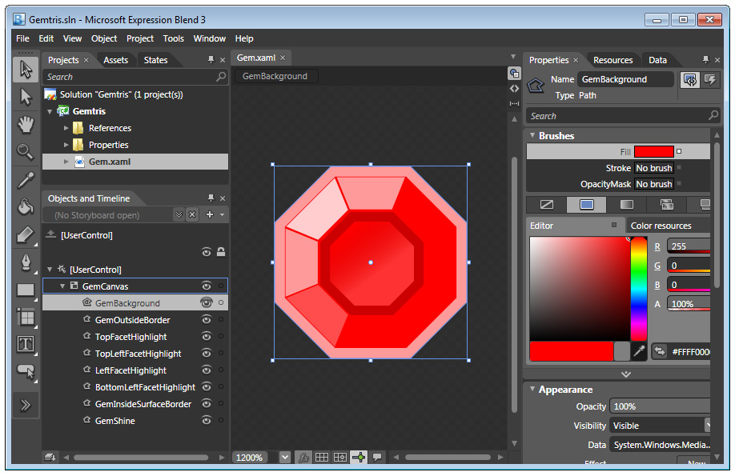
The final step of the design process: importing the Gem graphic into a UserControl
Adding Animation
So far our gem looks nice, but it’s a bit boring and static and lacks a bit of polish (pun intended). Silverlight provides us with an easy but powerful animation system. Lets use it!
One way to spice up gem block graphic is add a simple glimmer animation by moving a semi-opaque gradient over the gem shape. We can play this animation when the player completed a line, or when adding a new tetromino shape to the board.
From the Objects and Timeline panel in Expression Blend select the New… button to add a new Storyboard to the control, naming it “Glimmer”. We will later be able to access this storyboard via this name in our IronRuby code.
Add 4 keyframes to the Glimmer timeline and provide the key points of the overlaid-gradient transitioning from the top-left to the bottom-right, before fading out. Silverlight will fill in the between steps of these keyframe’s, a process called tweening.
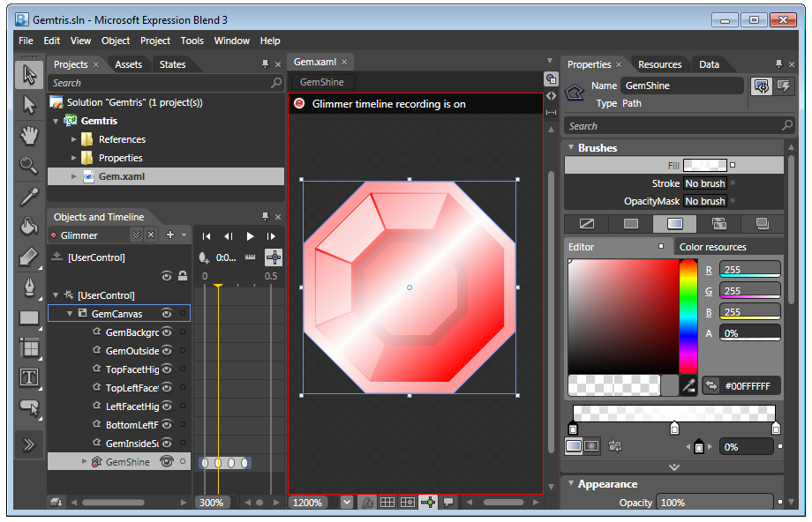
Creating the “Glimmer” Storyboard animation in Expression Blend
Compiling the project into an assembly
Congratulations, you’ve successfully built your gem piece control and you’re now ready to start putting some code behind it.
From the Project menu select the Build Project item to compile the .NET assembly. When the build is completed copy the outputted Gemtris.dll into your Silverlight application under the Gemtris/app/bin/ folder.
TIP: Store referenced files under the app folder
When Chiron builds your XAP file it’ll automatically include anything under the app/ folder for you, so it’s a good idea to keep anything you reference under this path. Otherwise you’ll need to remember to include /path switches in your Chiron command.
5.4 Laying out the game screen in XAML
Time to get your hands dirty. From our wireframes we identified a number of XAML elements that we’ll need for our Silverlight application, so lets start building up the game interface.
The generated template for our Silverlight application includes an example app.xaml file with a simple Hello World example. Using this XAML as a starting point lets add in a few Grid controls; one for the main game board (where our Gemtris.Gem blocks will go), one previewing the next shape to drop, and a couple to help layout all the elements.
##.## Laying out the Gemtris app.xaml
<UserControl
x:Class="System.Windows.Controls.UserControl"
xmlns="http://schemas.microsoft.com/client/2007"
xmlns:x="http://schemas.microsoft.com/winfx/2006/xaml">
<Grid VerticalAlignment="Center" HorizontalAlignment="Center">
<Grid.RowDefinitions>
<RowDefinition Height="*" />
</Grid.RowDefinitions>
<Grid.ColumnDefinitions>
<ColumnDefinition Width="220" />
<ColumnDefinition Width="150" />
</Grid.ColumnDefinitions>
<Border Grid.Row="0" Grid.Column="0"
Width="220" Height="334"
BorderBrush="White" BorderThickness="1">
<Border Padding="5"
BorderThickness="5" BorderBrush="#422">
<Border.Background>
<LinearGradientBrush StartPoint="0,0" EndPoint="0,0.7">
<GradientStop Color="#311" Offset="0.0" />
<GradientStop Color="#211" Offset="1.0" />
</LinearGradientBrush>
</Border.Background>
<Grid x:Name="boardGrid" VerticalAlignment="Stretch" 1
HorizontalAlignment="Stretch" />
</Border>
</Border>
<Grid Grid.Row="0" Grid.Column="1" Margin="5,0,0,0">
<Grid.RowDefinitions>
<RowDefinition Height="Auto" />
<RowDefinition Height="40" />
<RowDefinition Height="*" />
</Grid.RowDefinitions>
<Border Grid.Row="0" Margin="5,1,0,0" Padding="5"
BorderThickness="5" BorderBrush="#422">
<Grid x:Name="nextShape" Width="80" Height="40" /> 2
</Border>
<TextBlock Grid.Row="1" x:Name="completedLinesCount" Margin="5" 3
Text="Lines: 0" Foreground="White" FontSize="20" />
<StackPanel Grid.Row="2" VerticalAlignment="Bottom">
<Button x:Name="start_button" Content="Start Game" 4
FontSize="14" Margin="5,0,5,20" />
<Image Source="media/logo.png" Stretch="None" 5
Margin="0,0,5,10" />
</StackPanel>
</Grid>
</Grid>
</UserControl>
Cueballs in code and text
A TextBlock #3 is used to display the lines-completed counter. Having the game start when the app loads is a bit annoying, so we’ll use a button #4 to start the game instead.
For a bit of visual interest lets also add an Image #5. It’s Source attribute points to the Gemtris logo I’ve designed and exported with Photoshop as a PNG (saved under Gemtris/app/media/ to ensure it’s accessible).
That almost finishes off the main Gemtris screen layout. We’re obviously missing any in-game elements, so the next step is to put some of our pretty Gem graphics onto our game board Grid. In the next section we’ll discuss the ways of referencing and adding instance of the Gemtris.Gem CLR class we’ve designed in Expression Blend.
5.4.1 Referencing an assembly
Now that we have our Gem graphic compiled into a CLR assembly we have to create a reference to it in order to make use of it. There’s no code driving any behavior for it yet, it’s just an empty shell: a graphic and an empty class. We’ll fix that in the next section.
There are a couple of places that you can reference your assembly:
Referencing assemblies in XAML
To create a XAML element for your CLR class, such as <gemtris:Gem />, you’ll first need to tell the XAML processor a couple of things by adding a namespace to the XAML document. Give your XML namespace a meaningful name, such as gemtris. You’ll also need to provide the CLR namespace and assembly name in as named tokens within the declaration. Since we’ve placed the assembly DLL within the Gemtris/app/ path the mapped assembly should automatically be picked up at run time.
<UserControl
x:Class="System.Windows.Controls.UserControl"
xmlns="http://schemas.microsoft.com/client/2007"
xmlns:x="http://schemas.microsoft.com/winfx/2006/xaml"
xmlns:gemtris="clr-namespace:Gemtris;assembly=Gemtris">
Leave out the path to assemblies in XAML
If your assembly is under the app/ folder, or even in a descendent folder, you should just include the assembly name (leaving out the path to it). Silverlight will find them automatically.
Referencing assemblies in code
Requiring a CLR assembly in IronRuby is just like requiring any ruby class.
require 'bin/Gemtris.dll'
You can leave out the ‘.dll’ if you like, although it does provide an easy way of discerning between DLL and IronRuby code.
In IronRuby paths are important
Unlike XAML you’ll need to provide the correct paths. The base path of a Silverlight app is the app/ folder - it’s the folder used to create the XAP file - so ensure all your require’s are relative to this path.
5.4.2 Monkey patching a CLR class
Now that the CLR class is required into our IronRuby code we can make use of the dynamic nature of IronRuby and extend the Gemtris.Gem CLR class we built in section 5.3.2, attaching our own variables and methods. This method is called Monkey Patching, meaning that we are extending the runtime code of a dynamic language without altering the original source code.
By monkey patching the Gemtris.Gem CLR class we can take the graphics and animations, created by our designers with Blend for instance, and use them an empty shell; adding the required functionality to them using IronRuby code.
##.## Monkey Patching a CLR class
class Gemtris::Gem 1

def color=(color=Colors.Red) 2
# Get the Path that makes up the background of the gem, and memoize it
@gem_background ||= find_name('GemBackground') 3
@gem_background.fill = SolidColorBrush.new color
end

def glimmer
@glimmer_anim ||= find_name('Glimmer')
@glimmer_anim.begin 4
end

def show
self.visibility = Visibility.visible
end

def hide
self.visibility = Visibility.collapsed
end

end

- Open the namespaced class
- An example of extending a class with an IronRuby method
- Finding a named XAML element
- Playing a storyboard animation
Cueballs in code and text
Opening a namespaced CLR class and modifying it uses the same method as modifying a normal namespaced Ruby class. Simply define a class using the target class namespace, just as done in #1 where we’ve opened the Gemtris.Gem CLR class (Gemtris::Gem in IronRuby namespacing). Any methods defined with the class (such as #2) will now be available within the class.
Use the find_name method #3 to find a XAML element in the object tree with the x:Name attribute set. Any named element is findable, even non-UI elements such as Storyboard. Once you’ve found an element reference you can start calling methods on it, such as the Glimmer storyboard’s begin method #4.
The ||= operator
Ruby provides us with a handy condition assignment operator, ||=. For instance the statement x ||= 0 would be shorthand for x = x || 0.
This assignment is commonly used in Ruby to memoize a value. Memoizing is an optimization technique which stores (or memoizes) the result of a code statement, and on future calls to the same statement returns the memorized value (skipping the execution of the actual statement).
In Listing ##.## the result from the find_name request #4 is memorized into a class variable which will be returned on future requests, saving multiple lookups of the same XAML element.

##.## Adding controls to the view
As discussed in section ##.##, only CLR classes can be in XAML views because of the limitations of dynamic languages not implementing CLR reflection.
Because we’ve built our gem control with Expression Blend and generated a CLR assembly we can, however, reference the gem class from within the XAML. Our monkey patched methods will be available when we retrieve it form the view using find_name.
##.## Add a CLR class instance in XAML
<UserControl
x:Class="System.Windows.Controls.UserControl"
xmlns="http://schemas.microsoft.com/client/2007"
xmlns:x="http://schemas.microsoft.com/winfx/2006/xaml"
xmlns:gemtris="clr-namespace:Gemtris;assembly=Gemtris">
…
<Grid x:Name="boardGrid" VerticalAlignment="Stretch"
HorizontalAlignment="Stretch">
<Grid.RowDefinitions>
<RowDefinition /> 1
</Grid.RowDefinitions>
<Grid.ColumnDefinitions>
<ColumnDefinition /> 2
</Grid.ColumnDefinitions>
<gemtris:Gem x:Name="myGem" Grid.Row="0" Grid.Column="0" /> 3
</Grid>
…
</UserControl>
Cueballs in code and text
While being able to see your new Gem control within the XAML is useful for layout, for both designers and developers, it’s easier and more flexible to use IronRuby to add controls.
One of our code design requirements is to allow for a variable size Grid to display gem block pieces. Rigidly defining RowDefinition #1 and ColumnDefinitions #2 in XAML removes a lot of flexibility from our design, and means isn’t exactly terse when we need to define a 10x16 cell grid and add grid references to each Gem control #3.
Moving these sorts of Grid structure definitions makes perfect sense. Lets look at how we can accomplish a variable size Grid containing Gem controls of various states using IronRuby as part of the Gemtris::Display class.
##.## Creating XAML elements in IronRuby
require 'bin/gemtris.dll'
include Gemtris

# Display a Grid of Gems in various states
class Gemtris::Display

# A buffer for a new shape to be positioned in the state array
SHAPE_BUFFER_HEIGHT = 4

# Defaults for board width & height
DEFAULT_HEIGHT = 16
DEFAULT_WIDTH = 10

attr_reader :current_shape, :state, :buffer_height, :width, :height

# Pass in the Grid element to use as the display, and options for it
def initialize(grid, options = {}) 1
options = {
:height => DEFAULT_HEIGHT,
:width => DEFAULT_WIDTH,
:buffer_height => SHAPE_BUFFER_HEIGHT
}.merge(options)

@board_grid = grid
@height, @width, @buffer_height = 2
options[:height], options[:width], options[:buffer_height]

reset
end

def reset
@current_shape = nil
init_grid
init_state_array
end

# Set up the grid to have the right number of rows and columns
#
def init_grid
# remove any existing children from the XAML Grid element
@board_grid.children.clear 3

# add column definitions
@width.times {
@board_grid.column_definitions.add ColumnDefinition.new 4
}

# add row definitions and blank rows of gems
@height.times do |row_index|
@board_grid.row_definitions << RowDefinition.new 5
@width.times do |col_index|
# Create a new Gem control and configure it as blank
gem_block = Gem.new 6
gem_block.hide
# Position the gem in the Grid control
Grid.set_row(gem_block, row_index) 7
Grid.set_column(gem_block, col_index)
# Add the Gem to the Grid
@board_grid.children << gem_block 8
end
end
end

# Create a 2D array to store the game state. This array is inspected for
# state values when rendering the game board in the draw method.
#
def init_state_array
@state = Array.new(@height + @buffer_height) { Array.new(@width){ 0 } }
end

… snip …

- Passing grid and options
- Assigning width and height from merged options array
- Reset the grid by removing children
- Add a new ColumnDefinition element to the grid
- Add a new RowDefinition element to the grid
- Create a new Gem instance
- Use the Grid class set_row and set_column methods to position the Gem
- Include the Gem in the Grid’s children array

Cueballs in code and text
The human readable nature of IronRuby should make it relatively clear what’s going on here. The initialize method accepts a Grid element and some configuration options for the Display class and proceeds to call the reset method which sets up the Grid structures.
Reseting the display is basic. Remove any existing child elements from the Grid #3 and and create as many ColumnDefinition #4 and RowDefintion’s #5 as specified in the constructor options #1.
Iterating through every cell in the Grid instantiate a new, but initially hidden, Gemtris::Gem control #6 (the one we’ve previously designed in Blend and compiled to a CLR assembly), tell it where it should appear in the Grid structure #7 and finally place it in the view by appending it to the Grid’s children array.
Excellent. You’ve now built a IronRuby powered Gem Display control. We need to extend this a bit to provide the game functionality, like dropping a collection of Gems (the falling Tetris shape) and moving them around the Grid.
Extending the Gemtris::Display class with game functionality
The Gemtris::Board class inherits all the goodness of the Gemtris::Display class, it is after all a special case of a Grid that displays Gems. The job of the Board class is to track a falling shape (a group of Gems), position it on the grid using the Board’s state array, and remove any Grid rows when they become full (tracking the total number of lines completed).
##.## Gemtris::Board inheriting and extending Gemtris::Display
include Gemtris

# The game board
class Gemtris::Board < Gemtris::Display 1

attr_reader :current_shape

# Set up our game board to a blank state, ready for a new game of Gemtris
def reset
super 2
set_current_shape # pre-initialize the board with new shape
end

def set_current_shape(shape=nil)
super shape
# Position the shape to start in the shape buffer
@current_shape.y = -@current_shape.height
# Position the shape in the middle of the board
@current_shape.x = (width / 2) - (@current_shape.width / 2)
end

# Render the state array to the board and the boards current shape
def draw
@height.times do |row|
@width.times do |col|
# gem_at and state_at are declared in super class
g = gem_at(col, row)
pos_state = state_at(col, row)

case pos_state
when 0: 3
g.hide
g.color = Colors.black
else
shape_defn = Shape::SHAPES[pos_state]
g.color = shape_defn[:color]
g.show
end
end
end

@current_shape.draw
end

def remove_completed_rows
completed_lines_count = 0

# Go from bottom up
row = @height - 1
while row > 0
completed = true
@width.times do |col|
completed &= state_at(col, row) != 0
end
if completed 4
@width.times { |col| gem_at(col, row).glimmer }
completed_lines_count += 1
# remove row from state array
@state.slice!(@buffer_height + row) 5
# add blank row to the top of the state array
@state.unshift Array.new(@width) { 0 } 6
# don't decrement row as the line above has now dropped down
else
row -= 1 # process next row
end
end

completed_lines_count
end

end

- Inherit from the Gemtris::Display class
- Override the reset method
- Set the Gem’s visibility and color based on the state array
- Remove a completed row
- Deleting an array element
- Prepending a new array element
Cueballs in code and text
Apart from being a good demonstration of Ruby inheritence this code also makes use of a couple of interesting Array methods.
The slice! method #5 operates on an array, removing the passed indexed array item in place. slice! has a sister method, slice, which removes the indexed array item but not in place, and returns the modified array.
unshift is perhaps confusingly named for .NET developers, but can be thought of as prepend. Given an object it will insert it into the head (the 0th element) of an array, “shifting” every item after it along 1. There is, as you may have guessed, a corresponding method called shift, which removes (or pops) the first element from the array and shifts every item after it down 1.
Some of the code may be difficult to understand since we haven’t yet defined the Gemtris::Shape class. What does it do? Outlining the Shape class should help make all these classes a bit clearer.
##.## Shape: A strand of Gems
The shape, or more correctly in Tetris parlance, the “tetromino”, is a collection of blocks in one of a limited set of predefined arrangements. Anyone who’s ever played a falling-block game should know these shapes. They are generally referred to by letters that echo their outlines: I, J, L, O, S, T, and Z. Sticking with the letter naming convention lets create a class constant that utilises a named hash #1 of shape descriptions. There are only two bits of information needed to define a shape; it’s outline #2, represented by a 2D array, and the color of it’s Gems #3 (making use of the predefined System::Windows::Media::Colors set of colors).
##.## Shapes constants hash
class Gemtris::Shape

SHAPES = {
:I => { 1
:color => Colors.red, 2
:data => [
[1],
[1],
[1],
[1],
]
},
:J => {
:color => Colors.orange,
:data => [ 3
[1,1,1],
[0,0,1],
],
},
… snip …

Hopefully now you should be able to see that this is a game all about manipulating arrays. We have a 2D state array to represent the board, which has a falling shape defined by the 2D data array above, which in turn is used to turn off and on Gems (and set it’s color) on the board Grid.
It’s no surprise to find that the Shape class does a lot of work with 2D arrays, and we’ll look at how shapes are rotated and collisions detected using these arrays over the next few sections.
##.## Can haz random shape? kthnx bai
We’ve now defined all the possible configurations of a shape in our SHAPES constant. When we create a new Shape class instance lets pick one of these definitions randomly for the new Shape instance.

attr_reader :board
attr_accessor :x, :y

def initialize(board, key=Shape.random_key) 1
# Track the board we belong to
@board = board
@key = key

# Assign shape data based on the key passed in, or randomly generated
shape = SHAPES[ key ] 2

@x = @y = @orientation_index = 0
@color = shape[:color]

# Rotate the data array
@orientations = Shape.generate_orientations shape[:data]
end

def Shape.random_key
SHAPES.keys[ rand SHAPES.length ] 3
end

A quick solution to pick a random shape definition is to assign a default value to the key parameter passed to the initialize constructor #1. Default parameter values don’t have to be constant values. Instead we can call the static random_key #3 method, assigning it’s result to the key parameter.
random_key asks the SHAPES hash for a array of all it’s hash-keys. It can then return a random key from this array, which is then used to look up the hash definition #2.
##.## Elegant ruby: rotating a 2D array
Any tetromino shape can be rotated 360 degrees in 90-degree increments. The Shape’s 2D data array must represent this. Rotating a 2D array can be done a number of ways. In C-like languages this operation is often performed by mapping one cell to another, and tends to be long and complicated. It’s made more complicated by the fact our shapes aren’t of equal height and width.
IronRuby, on the other hand, makes this beautifully easy and elegant. So elegant in fact we can accomplish it with only one line of code.
Adding a rotate! method to the IronRuby Array object requires creating a file to hold your extension. The Ruby convention is to place any such extensions to core objects under the lib/core_ext/ folder (lib/core_ext/array.rb in this case). This makes it easy for future developers to trace any custom methods on objects. Remember to require this file in your code. Your rotate! Method won’t be included otherwise.

require 'lib/core_ext/array'
##.## Extending Array with rotate!
class Array

def rotate!(n=1)
(n%4).times {self.replace(self.reverse.transpose)}
self
end

end

# Check it out – rotate a 2D array 90 degrees
[[1,2,3],
[4,5,6]].rotate!
=> [[4, 1], [5, 2], [6, 3]]

This is hardcore. Even for a seasoned Rubyist. This is one to impress your friends with.
Making use of the age-old programmers friend, modulo %, we limit n to the range 0 to 3. Performing the proc supplied to the Array.times method will effectively rotate the array the required number of degrees (90, 180, 270, 360 degrees).
The wizard behind the curtain here is actually the self.reverse.transpose passed to self.replace. Transposition is a term you may have encountered in linear algebra classes when talking about matrices. Simply put it means, “write the rows as columns”; which thought of graphically is a 90-degree rotation, right? The problem is you just can’t keep transposing the array, as transposing a transposed array results in the original array. Phew.
The reverse method does what you’d expect and reverses the order of the array elements. Thinking of that graphically we’ve just flipped the array horizontally. But, and here’s the white rabbit in the hat, by teaming this up with transpose it allows us to keep performing transposition on the previously transposed array. Once again thinking graphically, this means 2D array rotation!
What a trooper of a language! Look at home much functionality has been compressed into this single, elegant, and beautiful line of Ruby. This author dares you, my dear reader, to find a more elegant solution in a procedural language.
Pre-computing rotations for a Shape
We can now use our array rotate method to compute the rotations for any shape. Because there are only 4 possible orientations for a shape we can compute this up-front.
def self.generate_orientations(shape_array)
# Add the initial shape into the array
orientations = [ shape_array ]

# Now rotate the previously rotated array around 90, 180, 270 degrees
3.times do
orientations << orientations[-1].dup.rotate!
end

orientations
end
Now all that’s left is to store an index into the orientations array. Rotating the shape is then only a matter of modifying this index value. Here’s the Shape class’ rotate method:
def rotate
old_index = @orientation_index
@orientation_index = (@orientation_index + 1) % 4

# new orientation collides or out of bounds
if will_collide?
out_of_bounds_right = (x + width > board.width)
if out_of_bounds_right
proposed_x = (board.width - width)
# proposal is good, move shape to fix on screen
if will_collide?(proposed_x) == false
@x = proposed_x
return
end
end

@orientation_index = old_index
end
end
But what happens if we try to rotate into an existing shape, of if we’re at the far right hand edge of the board? We’re going to need some way of making sure we don’t bang into anything. We’ll define the will_collide? method to do just that in the next section.
##.## Bump! Detecting collisions
Detecting when blocks collide is at the crux of Tetris. We need to know where a falling shape can and cannot move to, and when it’s finally reached as far down the grid as possible.
##.## Detecting a collision
def will_collide?(x=@x, y=@y)
height.times do |row|
width.times do |col|
if (row+y == board.height) || 1
(col+x < 0) || 2
(col+x > board.width) || 3
(data[row][col] != 0 && board.state_at(col+x, row+y) != 0) 4
return true
end
end
end
false
end

- Reached the bottom of the board
- Moved out of bounds left
- Moved out of bounds right
- Collides with a neighboring block

The board’s state array
##.## Move it!
A Shape can move around the board left, right, and down. Lets model those directions using symbols, to keep our code nice and readable.
##.## The Shape.move method
def move(direction)
dx = dy = 0
case direction
when :right :
dx = +1
when :left :
dx = -1
when :down :
dy = +1
end

# Ask if this new coordinates would collide with something on the board
collided = will_collide?(@x + dx, @y + dy)

# If they don't collide move the shape
if not collided
@x += dx
@y += dy
end

collided == false
end
The logic is straightforward: Switched using the case statement on the direction symbol sent to the method it will move the shape by incrementing or decrementing the value of X or Y, but only if there was no collision at the future coordinates.
A trap for the Ruby-Newbie: Incrementing and decrementing numbers
For developers coming to Ruby from other languages like the members of the C family (C, C++, C#, Java) there are confusing differences with incrementing or decrementing operators. In Ruby there are none!
i++ or i-- will not even parse as valid Ruby. Worse still ++i or --i will parse fine, but will be interpreted as being multi unary operators (+i == ++i == +++i).
In Ruby you should increment or decrement numbers using self-assignment operators like += or -= instead. For example i += 1, and i -= 1
Reducing RSI: Dropping the Shape
Tapping away like a maniac on the down arrow key to move a shape piece into place can be aggravating for RSI sufferers, so let’s write a really quick drop method that will drop a shape as far down the board as possible before it collides with another block.
Taking advantage of Ruby’s relaxed if statement syntax and recursion we can alleviate our own RSI as we can write yet another elegant one-liner.
##.## Dropping a shape into place
def drop
drop if move(:down)
end
If the shape moved down successfully (i.e. move returned true) then recursively call the drop method. As soon as the move method fails the recursion unravels, and we have successfully moved the shape as close to the bottom of the game board as possible.

Game manager
- constructor pulls things together
- timer options
- events for keyboard and start button
- sounds
Networking high-scores service and calls
Data binding to XML
Gestalt

